Lee SangJoon (Bob)

01/10/2015

Prof Petrillo

**Audio Bike Navigation Research**

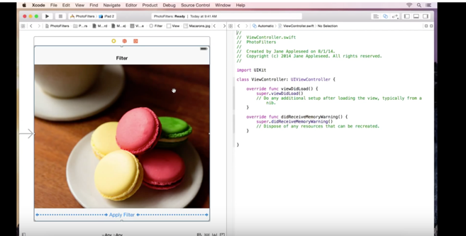[1]

[2]For our audio only bike navigation, we must consider various aspects, including our customer segments, competition with other businesses, and technological aspects such as Bluetooth, programming an app, and connecting with Google Map. In this paper, however, I will focus on two aspects: an App programming and predicting the cost of connecting with telephone Carriers such as At&T, T-Mobile, and Verizon to provide a hotspot that is connected to the audio navigation so that foreigners are able to use the internet and connect their smartphones for using Google Map and searching for famous places in New York City.

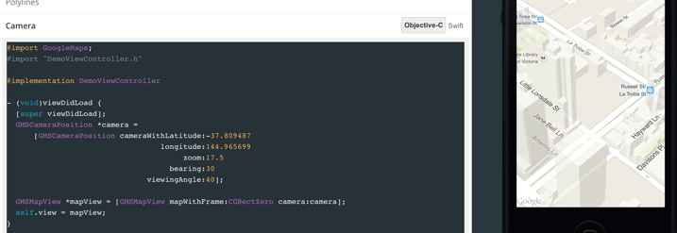 First of all, I would like to briefly mention how to build an app. Although I am a beginner in coding, using X-code, a built in programming software, can be used for designing and coding for creating an app. However, we must consider how we can program so that we can combine Google Map inserted into the App. Although I have not performed it yet, Google seems to provide a free license for using Google Map in a built in app according to Google Developers. [3] Furthermore, there is a way to code and put the map inserted by following sample code suggested by Google[4]. Although building an app and inserting Google Map seem very challenging, I shall give a shot and understand my limitation because there are other tasks to be done regarding to programming, including Audio navigation.

More importantly, in this paragraph, I will discuss on cost that would occur from our plan to insert a 4G/LTE sim card so that it could be used as a hotspot that would provide the internet for the foreigners. Currently, T-Mobile provides a hotspot device which would cost $20 per month including 1GB LTE and unlimited slower data.[5] By implementing the internet hotspot within the audio navigation device, we are able to provide the internet for foreigners, thus they are able to navigate themselves throughout the city. However, now, we must consider how much actually the device would cost. From the customer’s point of view, he/she needs to purchase a bike, the device, and also a lock just for a couple days of weeks for traveling. In my opinion, instead of selling the audio navigation devices to foreigners, our business plan should rather focus on “renting” a set of items which include, a bike for traveling, the audio navigation device, and lock. By purchasing the set of the items, foreigners do not have to worry about searching for free wifi, or buy another number from a carrier which automatically charges $50 per month even though foreigners may stay only a couple of days to weeks. I believe that we can rent the set of items, so that we not only be able to use our audio navigation devices and bikes over and over and provide a great service for foreigners as well.

1. https://www.youtube.com/watch?t=373&v=9WXUug6Z8gQ
2.
3. https://developers.google.com/maps/pricing-and-plans/
4. https://developers.google.com/maps/documentation/ios-sdk/
5. https://t-mobile.com/add-to-cart.step2.mbb.a7d91f0e-8274-4a41-b7bf 42653fd76ef4.html